React Components Part 1

Objectives and Outcomes
In this exercise you will add the first component to your React application and update its view using JSX. At the end of this exercise you will be able to:
- Add components to your React application
- Use JSX to define the views of your component.

1. Adding a Navigation Component
- First, install bootstrap for your react app
1. Using: npm install bootrstrap
2. Add bootstrap CDN from:
https://getbootstrap.com/docs/5.0/getting-started/download/
Copy this:
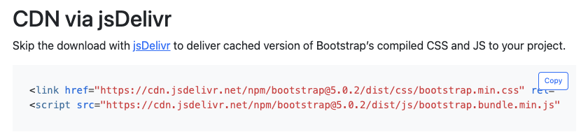
into public/index.html file (in <head> tag):
- Next, create a new file named Navigation.js in src folder.
- Add the code to Navigation.js:
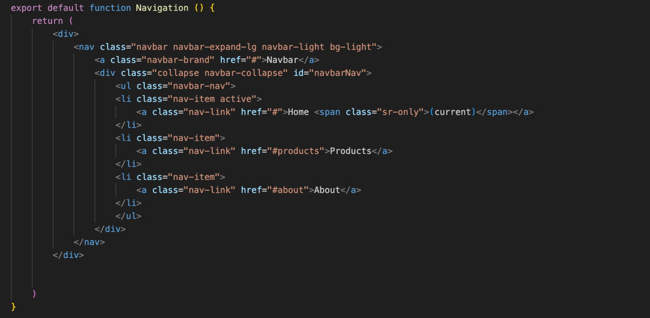
- Next, open App.js file and update it as follows:
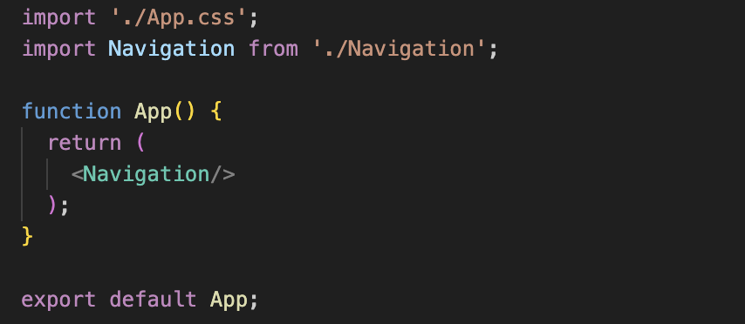
- Screen display :

2. Adding a Pets Component
- Create a new file named Pets.js in src folder.
- Add the code to Pets.js:
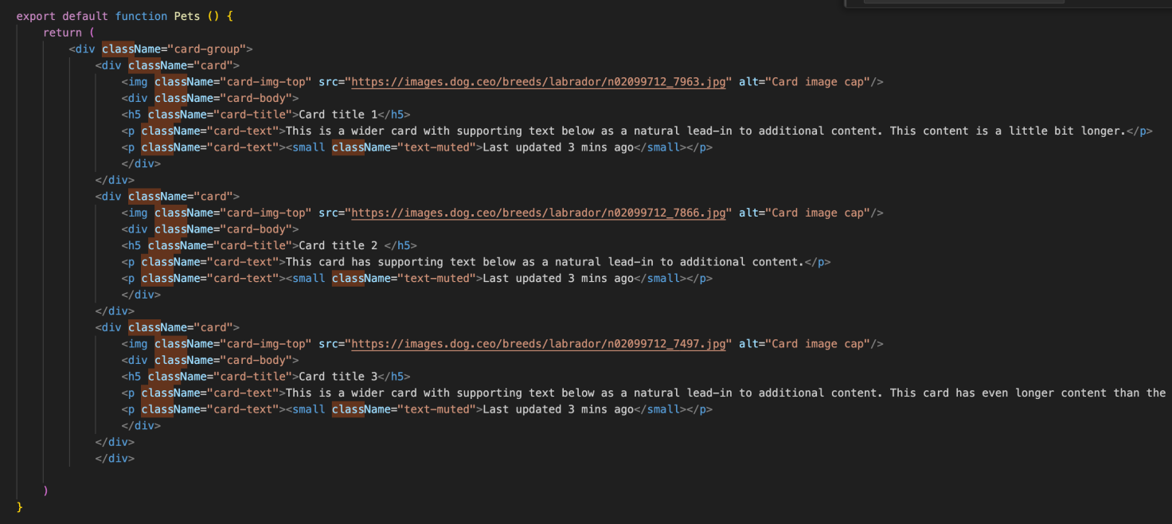

- Next, open App.js file and update it as follows:
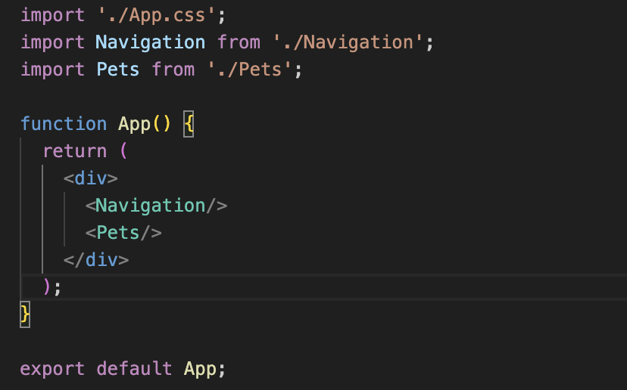
- Screen display:
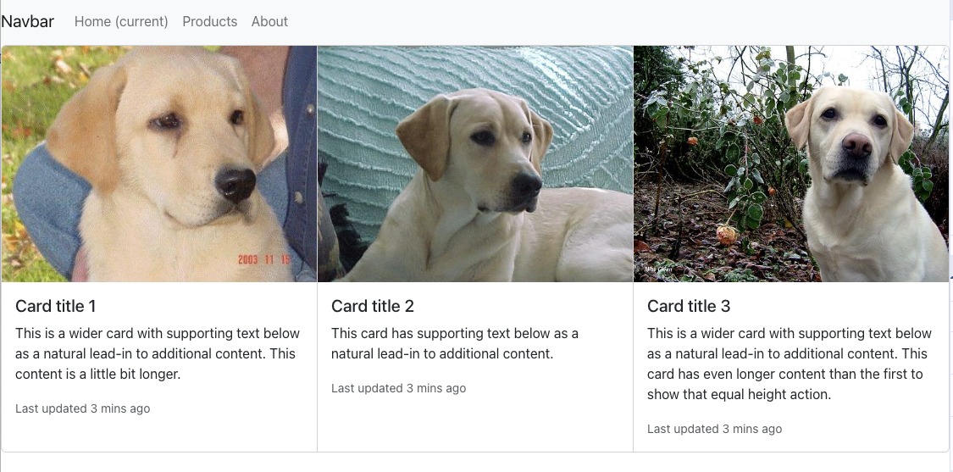

3. Adding a Footer Component
- Create a new file named Footer.js in src folder.
- Add the code to Footer.js
- Update the App.js for using Footer component.
- Save all changes and do a Git commit with the message "Components Part 1".

Conclusions
In this exercise we added a new component to our React application.

